SUPPLEMENTARY NOTES FOR MY REVIEW OF WEBSITE UPDATED ON 5.5.25

Dear Kiann Tech,

This document supplements my review (5.5.25 degerlemesi.docx) with additional context to clarify the issues and updates needed for Smart Life Academy’s May 15, 2025 launch.

**Recent Changes and Clarifications**

- **Test Retake Bug (Items 3, 7, 14)**: I noted a new issue: users can retake tests on subsequent days, which violates the spec (Section 4, Test Logic: "Each book’s test can be taken only once; no retakes," and "Users are limited to taking 10 tests per day"). For example, in Item 3, I took a test, and the next day I was allowed to retake it. This should not happen. The system should show the previous answers and navigate back (Item 14, image22.png). Fix this to enforce the one-time test rule, allowing up to 10 tests per day only for different books.

- **Commission Tracking Consistency (Items 4, 12)**: The user-side "My Commissions" page lacks the month function and table (email, plan, commission, monthly total), which was previously a demo (Item 4). The admin-side commission tracking shows incorrect data (e.g., 35.92 instead of 0 for February, Item 12). Per the spec (Section 2, My Commissions; Section 6, Commission Monitoring), both views should have a "Select Month" dropdown and match exactly. This ensures I can monitor user earnings accurately.

- **Challenge Completion Email (Item 5)**: I clarified that email notifications should trigger only for successful 30-day challenge completions (30 books marked "Completed Successfully" across 10 distinct days). The email should include just the user’s email address, as I’ll check details in the admin panel.

**Critical Issues to Prioritize**

- **Book Duplication (Items 7, 11)**: The same book is counted multiple times in "My Completed Books" and admin panel (e.g., 4 entries for one book). Per the spec (Section 2, Completed Books; Section 6, Challenge Monitoring), each book should be counted once with dynamic status updates: "Incomplete" (<100% listened), "Completed" (100% listened, test failed), "Completed Successfully" (100% listened, test passed with 80%+ on first attempt).

- **Storage Limit (Item 14)**: The 8 MB limit still blocks book uploads, despite my Backblaze B2 proposal (due 4/24). This is urgent to enable content uploads.

- **Testing Setup (Items 8, 9, 12)**: Reset Raju to a 1-month plan with some referrals (e.g., 2 friends who purchased plans) and clear his book readings. This allows me to test the 30-day challenge progress and commission tracking fully, ensuring all features work as expected.

**Why This Matters**

These fixes are critical for a smooth launch. The test retake bug undermines the challenge’s integrity, incorrect commission data affects trust, and the storage limit blocks content. Your recent updates (e.g., month functions, plan upgrades) are impressive—let’s finalize these last issues to ensure success.

Best,

SERDAR

Now generally is only refinements not the general structure.

USER LOGIN ITEMS

Item 1 Sign up page . please add this details in Sign UP page in the middle or somewhere suitable

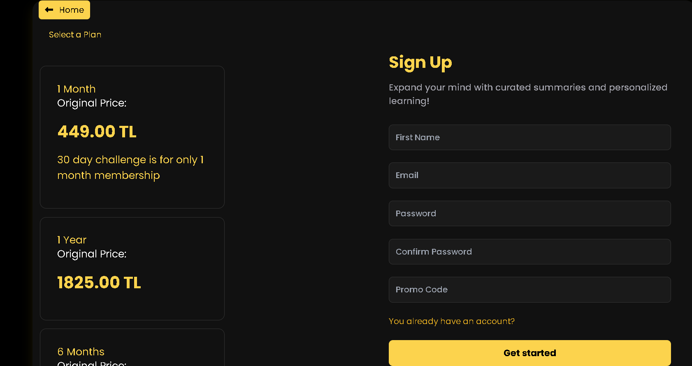

*“Welcome to Smart Life Academy!*

*Join a thriving community dedicated to personal growth with curated book summaries and personalized learning! Sign up to unlock your potential with flexible plans:*

* ***1 Month****: 449.00 TL – Includes the exclusive 30 Days 30 Books Challenge. Complete 30 books with 80%+ test scores across 10+ days to earn 11 months free!*
* ***6 Months****: 1349.00 TL – Save with a mid-term commitment, upgradable to 1-year.*
* ***1 Year****: 1825.00 TL – Best value for long-term growth.*

*Upgrade anytime to longer terms (e.g., 1-month to 6-month or 1-year, or 6-month to 1-year) to lock in savings, but downgrades are not allowed until your current term ends. No refunds are offered due to our referral commissions and challenge rewards, though you can use all services until your paid period ends if you cancel. A new promo code will be issued if you rejoin.*

*Sign up now, share your unique promo code to earn commissions, and start your growth journey!”*

ITEM 2 chatbot location

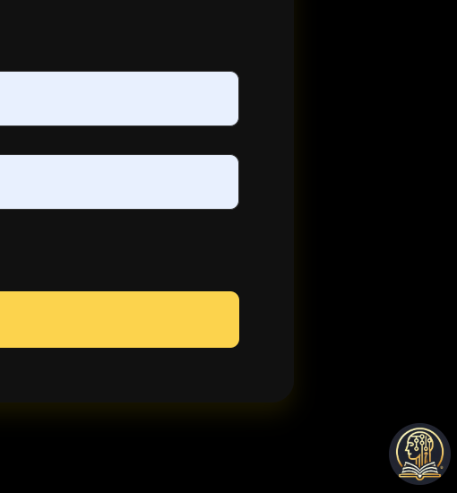 I see this chatbot which is sales support bot even after log in , we should see the life coach robot after login not this one this chatbot is available in the landing page only, nowhere else, even log in page we don’t need to see it will confuse users , so please remove this one from the login box , and after login in they will see the other robot not this one . . it sometimes keep the this robot above in login page . but sometimes does it correctly and shows the life coach chatbot. Like below . lets make sure it always work like that . in short

1 in landing page only sales chatbot the one you see above,

2 in sign in page we can keep the sales chatbot robot , but in login no chatbot like above (above picture is login page )

3 after login everytime we see the life coach boat. Please make sure that all 3 everytime

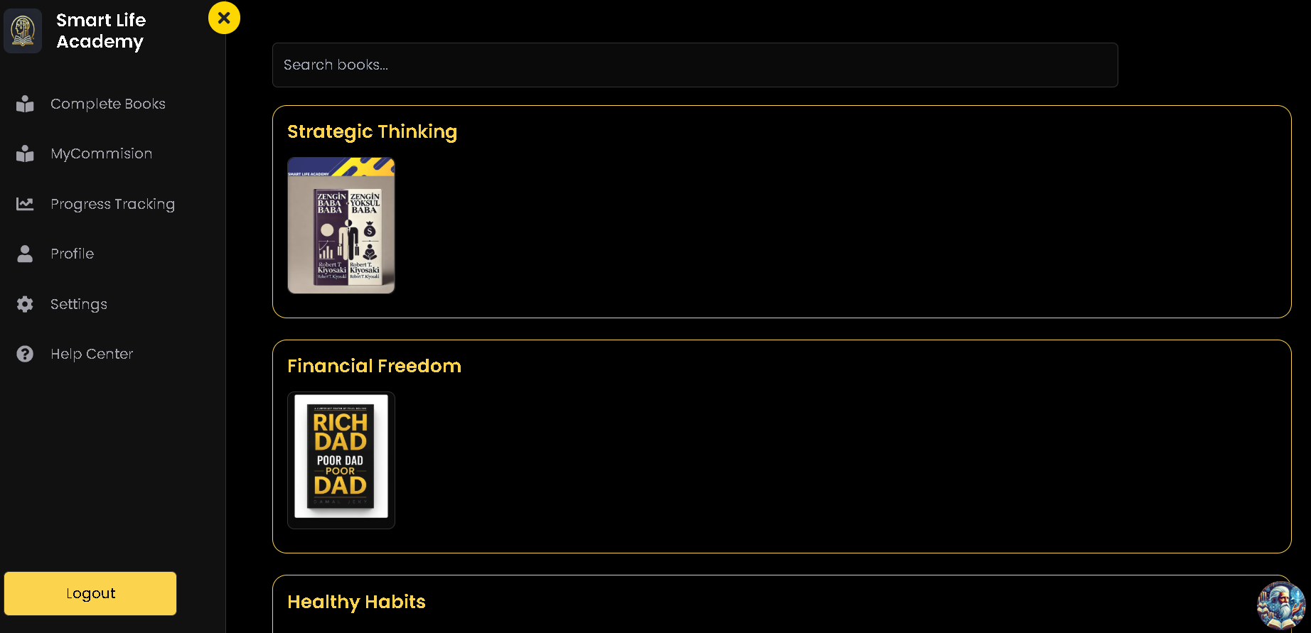

This one correct bot in user login page .

Item 3 My completed books menu

I see that his test results 100% , above 80% is passing score, since he has to listen the book first 100% then he can take the test. When he complete the book 100% audio , it will wite completed but like he also pass the test so it should marked as After that, if they take the test and pass with at least 80% success (4/5 correct on the first attempt), the book is marked as "Completed Successfully" with a (*) next to the book name in the "Completed Books" menu. This status is also reflected in the 30 Days 30 Books Challenge progress tracking.

So lets make sure this works as follow 100% of the time .like this

• Earlier, we had a mix of "Incomplete" and "Uncompleted" terminology, but we’ve standardized it for consistency. People who start reading a book but don’t finish (less than 100% listened) are marked as "Incomplete."

• If someone listens to 100% of the book summary, the status updates to "Completed."

• After that, if they take the test and pass with at least 80% success (4/5 correct on the first attempt), the book is marked as "Completed Successfully" with a (*) next to the book name in the "Completed Books" menu. This status is also reflected in the 30 Days 30 Books Challenge progress tracking.

• The 30 Days 30 Books Challenge is indeed exclusive to those who purchased the 1-month plan (priced at 449 TL), as outlined in both the promotion document and technical specification. Completing 30 books as "Completed Successfully" across at least 10 distinct days within 30 days earns them 11 months free.

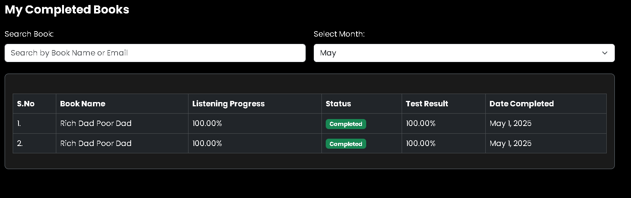

By the way I like the month function that’s so cool and usefull

ITEM 4 My Commissions

There are few points regarding this item of my commissions

1 I don’t see anything here before he had a table showing 1 other friends e mail and 2 the plan they bought and 3 the commission they made because of that purchase . and under the table the commission they earned that month,

2 next to money put a status (like 1 paid it will take 2 3 business days to reflect on the account , or 2 will be paid in the beginning of next month. ) as a status which will be connected to payment system ,

3also this needs to be monthly just like the function on the books so user can see what he did in previous months.

That way this function easy to use and also motivating to make sales . This is a feel good page for the people who like to recommend good things to other people. So they can now make money with our system .

NOTE : Lastly as you know whatever user can see in his my commission page table I will be able to see what he did that month when I click on the promo code in from admin login , commission tracking panel.this will come up in admin login. Therefore I am trying to simplify the process.

Please make sure this table is no longer demo and it actually works above scnerio. So in next update please update fully functional like we are going to lunch. Soon.

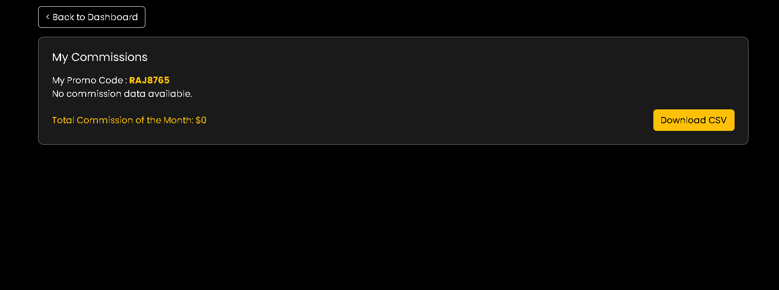

ITEM 5 30 day challenge process

Please make sure this 30 days Challenge starts in the moment when they purchase the 1 month plan and this is only available for the 1 month plan , and not available for 6 month and 1 year plans and works with tests results which they can only take the test after finishing the audiobook. Therefore please make sure all this function works accordingly so we can grant access to people 11 months free membership (by the way I will do 11 months free in the beginning by monitoring ,and granting the 11 months manually

1 so whenever person finishes 30 day challenge successfully I should be notified by e mail. (getting their e mail address is enough I can see what they did from the admin panel , Like I can receive e mail saying that this person completed the 30 day challenge= e mail address ) , So please add this function to notify me by e mail. Please add this connection to email for important notificication.

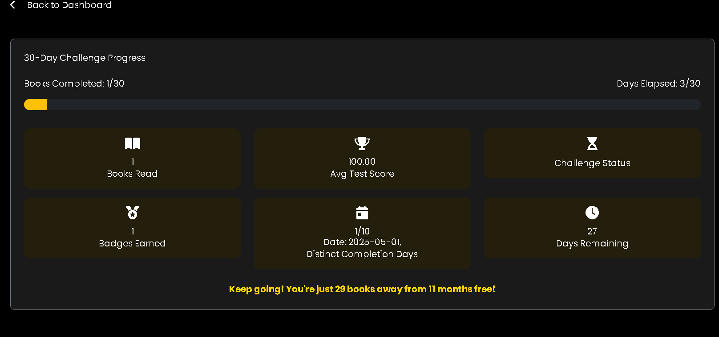

Item 6 Settings item

1. **Add a e mail function** : next to cancel button, you added ” this will also cancel your promo code and future commission payments” which is great And if the user still want to cancel, please let system send me message with title someone wants to cancel the service user e mail:…… very simple one all I need is to have the e mail of the user e mailed to me. I want to see why they want to cancel then I will cancel. I can ask questions before cancel it Especially in the beginning so I can use this as a marketing tool to improve user experience,
2. **Add this informa**tion in here

I played with upgrading different plans I was able to apply different plans user had 1 mont plan but I was able to upgrade to 6 months and later to 1 year. Which is great I see that he can only upgrade to bigger plan not smaller works great. Apply this logic just like that. Good job.!!

But On the right side there is enough room to say

*“Welcome to Smart Life Academy!*

*Congratulations on joining us! You’re now part of a community dedicated to personal growth with curated book summaries and personalized learning. If you have 1-month plan, you can access the exclusive 30 Days 30 Books Challenge—complete 30 books with 80%+ test scores across 10+ days to earn 11 months free!*

*Upgrade your plan anytime to longer terms (e.g.if you have 1 month you can upgrade to , 6-month or 1-year or If you have 6 month plan you can only upgrade to 1 year plan) to lock in savings, but note you can only upgrade, not downgrade, until your current term ends. No refunds are offered due to our referral commissions and challenge rewards, but you can use all services until your paid period ends if you cancel. A new promo code will be issued if you rejoin.*

*Explore your dashboard to start learning, track progress, and earn commissions by sharing your unique promo code. Let’s grow together!*

*Get Started “*

they will know the logic and not confused how everything works

here you can put this information ,… right side 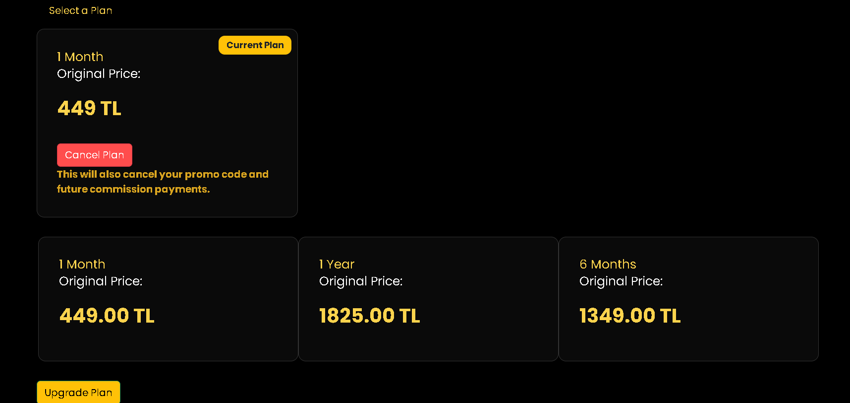

ITEM 7 very nice that books has search function thank you. *This item also related to ITEM 3 look at the item 3 as well, I experience this after reading the book and taking the test*

Also I tried to read book 100 percent finished the audiobook then it gave me access to write comment then It gave me access to test, which I passed and it marked as %100 completed successfully and successfully, but when I click again on test my knowledge it showed me the answers of the question and did not let me take the test again. Which is Amazing perfect .good job until here.

But it by mistakenly counts same book twice as you can see below I think you should tweak the system avoid counting same book for more than 1

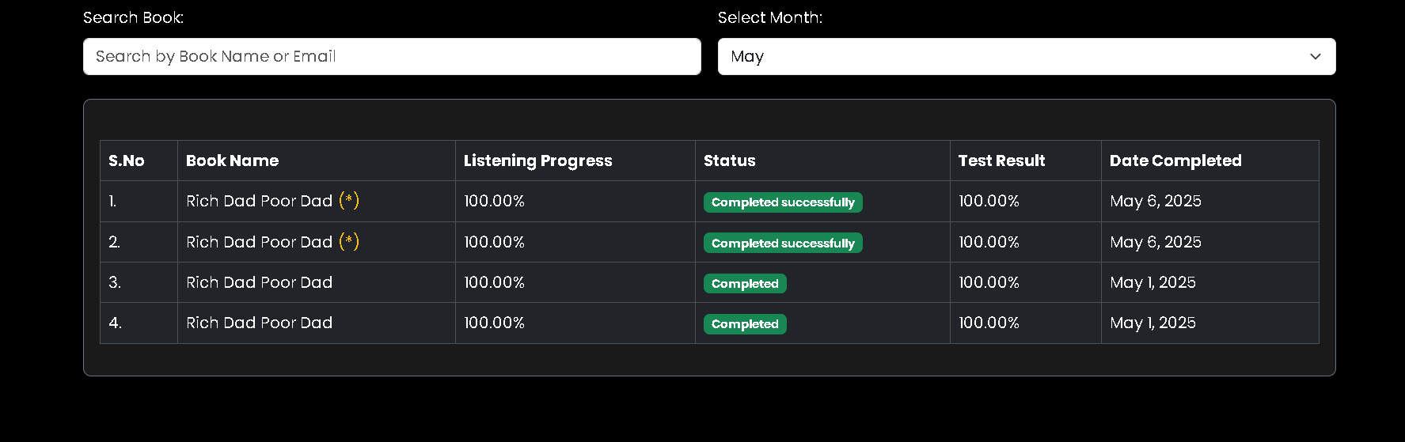

Compare above image with item 3 image , same book is counted 4 times. Same book should be counted only once, and status will appear as soon as user starts listening the audio book , and

1if he stops using and looks here same table he would see his listening progress (less than 100%) and status “incomplete”

2if he finish listening book 100 percent then it would show 100% and status “completed”

3 and lastly if he pass the tests status “completed successfully”

Also I noticed it did not let me take the test again because I already took it earlier great JOB

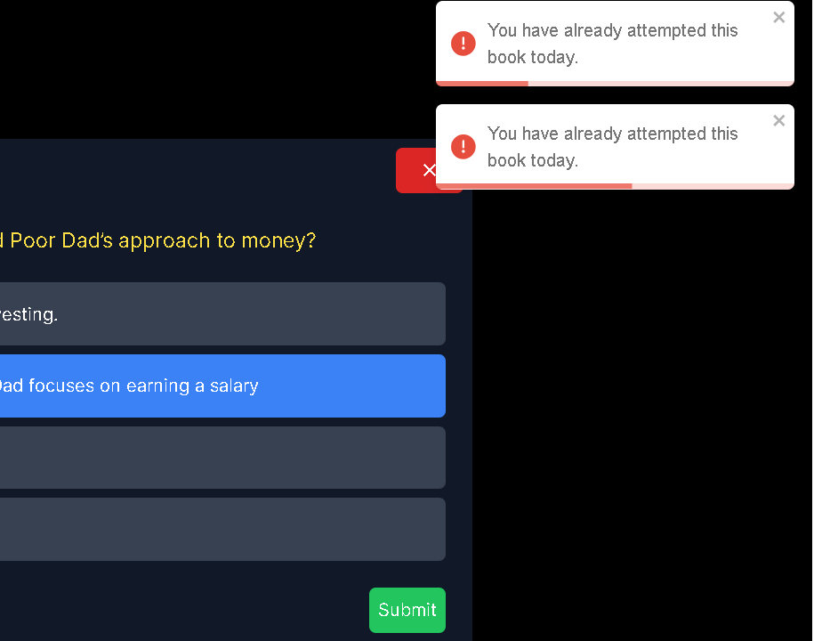

Important note Meantime next day I tried to take the test which allow me to to take the test, it should not allow me to take the test more than 1 time , regardless of the result. He can take up to 10 test per day . (assuming he listened the 10 different books 100%) but never be able to take the same test again lets keep it simple, process, each book test can be taken only once ,

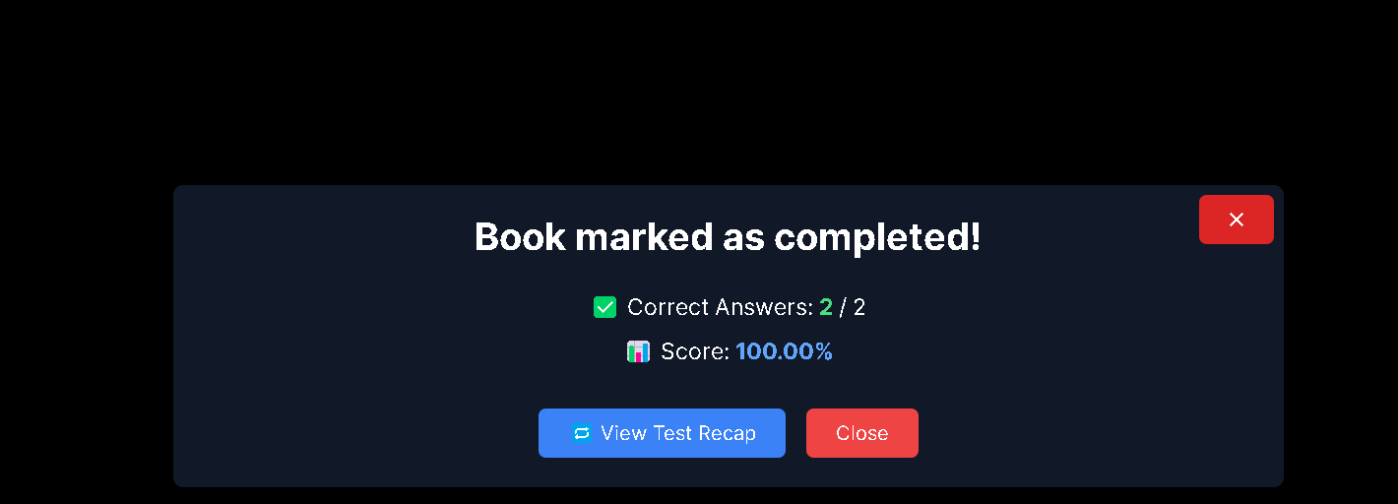

ITEM 8 **I have changed the plans and created some issues**

While in USER LOGIN using Raju I was going to check the”30 day challenge progress” after listening the book if finishing book with “successfully completed “ status would reflect on the table, but earlier I was playing with changing the plan. And I upgraded to 1 year that’s why now I can not see 30 day challenge progress sub menu here. Which is great that means the plan changes are reflected here.

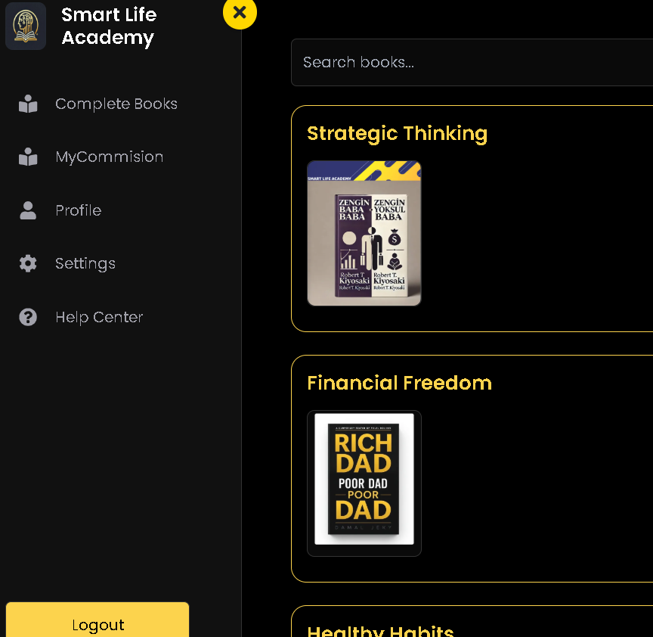

So can you please re start raju position as 1 month plan? And reset the book readings so I can test the reading 100% with test passing and see how it is reflected in book completed menu and the 30 day challenge, ok? Basically I want to see this table below affected when I read the first book. And once I test these functions then I will check the changing plan function . do you see what I mean? I just need reset book readings to zero. And also raju to be in 1 month program again for testing purposes .

The table I could not see is below due to changing plans

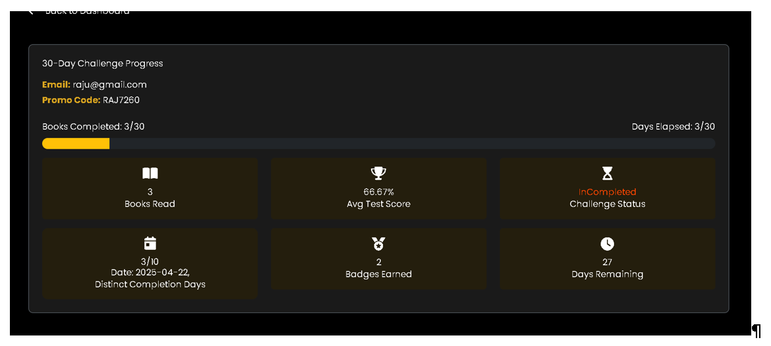

When I tried to down grade to 1 month it gave me this message . perfect this is what I wanted it to do. Perfect. .

But to check the 30 day challenge I need to change his status to 1 month plan, Do you think I can change his status from Admin panel? I will try

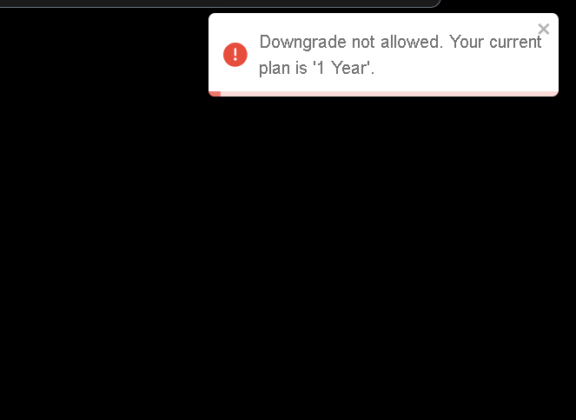

ADMIN SIDE ITEMS

ITEM 9 ALL USER items Lets add function that I can change users plan or other parametes and save it. yes I opened all users and yess yess I reach raju information *(earlier I was loking as user raju)* as I changed the plan he is on 1 year program. That means I cant see him in 30 day challenge, I was going to look up his 30 day challenge status (not possible that becase he has 1 year plan now) and his commissions , because raju did not have any refferals yet, so what I am saying I should be able to change his plan here if there is a mistake or when a person completes the 30 day challenge

So I need to make changes of this info manually when necessary like his plan or banking info later.

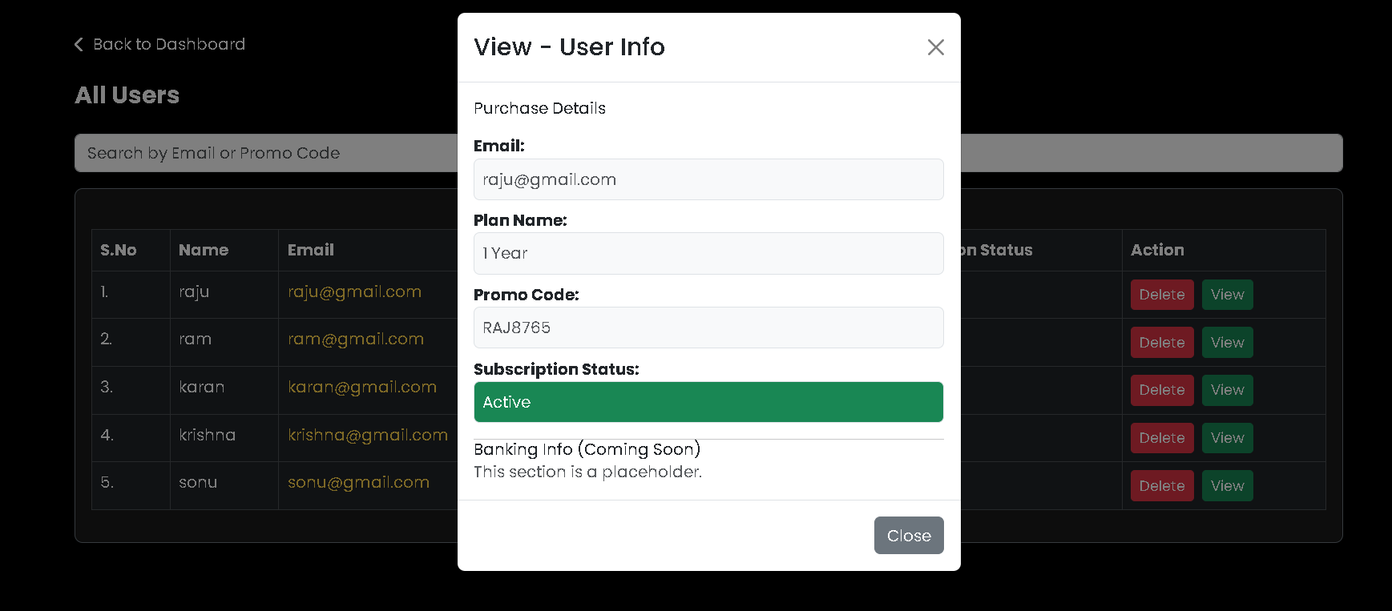

Please note I was able to delete the Sonu.last user above list .

ITEM 10 I tried the rewievs side its working great, Thank you

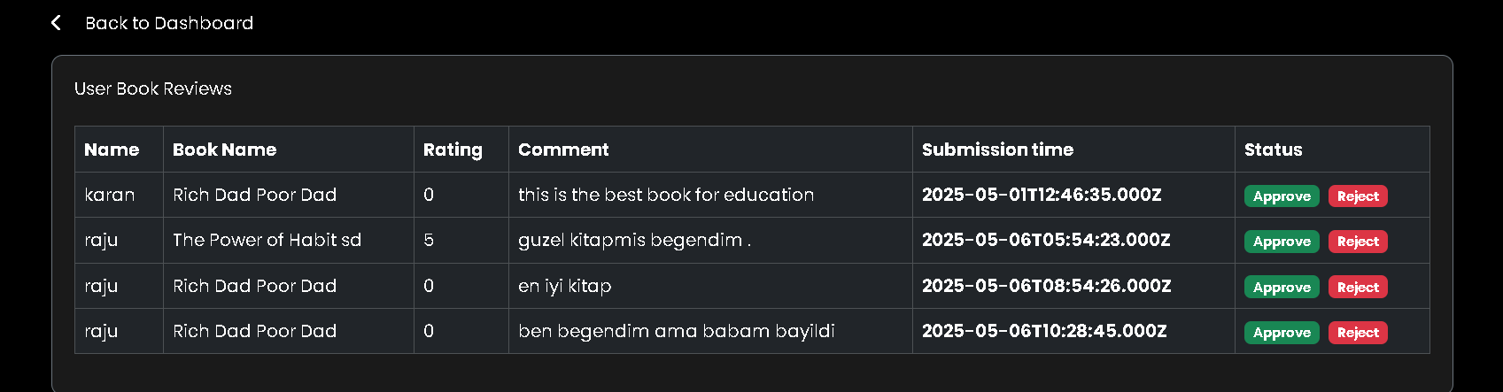

Item 11 Regarding the book read in admin panel due to doubling the entry of book names we see this one same book tested several times and also showing here , This item also related to item 7

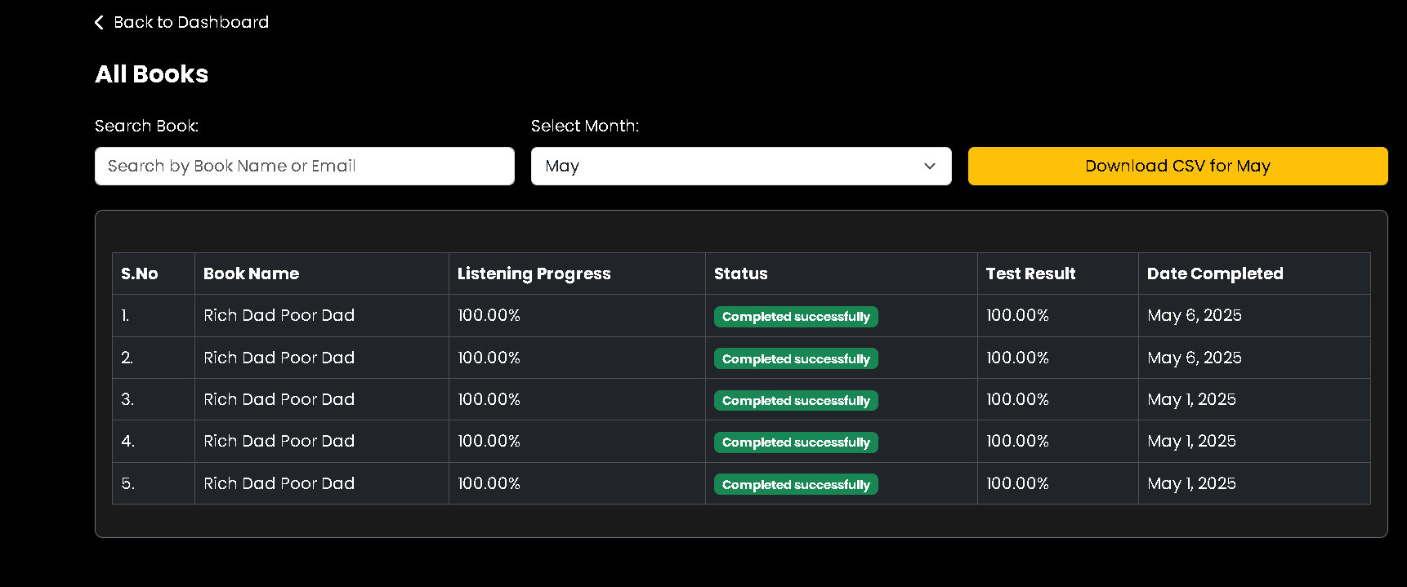

4 times same book entered here,

ITEM 12 ADMIN MENU thank you for adding month function on the commissioning tracking that’s really great *some reason it was not available for user login for some reason please refer ITEM 4 I thought I can see same what user can see in admin panel lets make sure my commissions and 30 day challenge pages are shared within the admin panel. This will help streamlibe the process .* but previous month showing 35 instead of 0 please refer below this needs to work for all months, user might say I did not receive money in february then I will have problem this function needs to work 100% 7 24 (I reach here from admin panel in admin login commission tracking and clicked on the promo code. I want to see same for raju login,. Can you set up raju has some referalls along with he is 1 month plan, so I can read and listen the books and see its reflected in book read and my commissions page , later I can see all those parameters in the admin login.

*It shows 35.92 instead of 0* FOR February

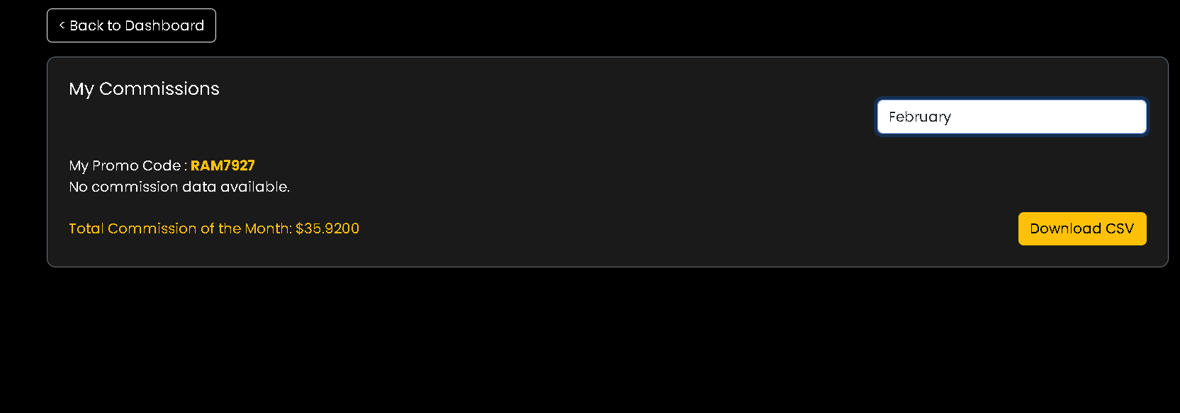

Here ise the original menu (below I click on promo code ) where I reach above ,page . also below I clicked on e mails and they worked very good by taking me back to users 30 day challenge page . good job.

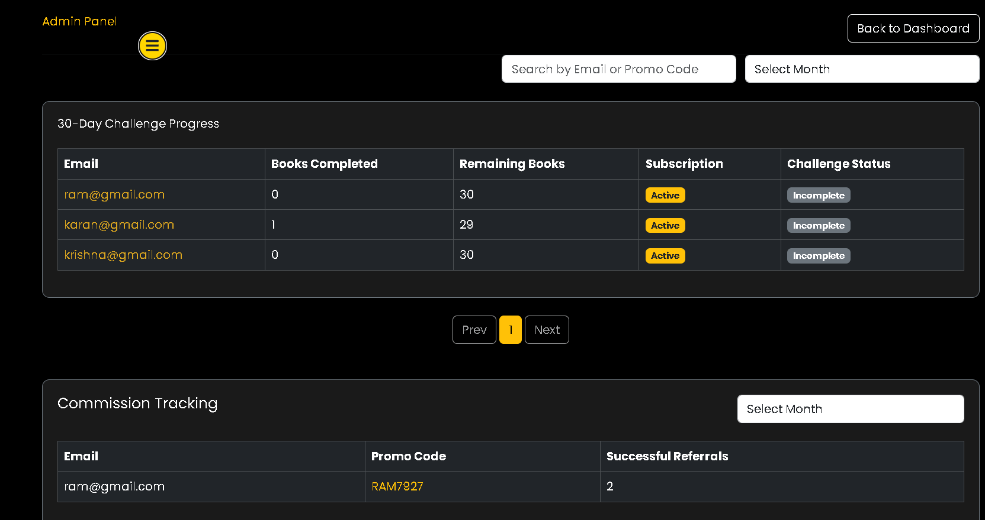

Item 13 All ViSITORS looks good (assuming we cachth that information when purchase is completed)

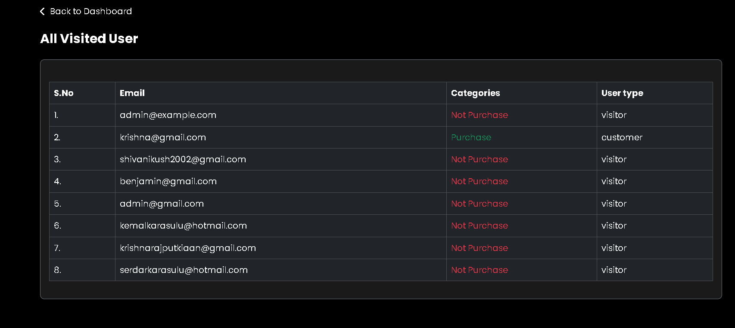

14 BOOK MANAGEMENT SYSTEM I still can not upload audio books due to limitation 8mb you were going to come up with solution earlier?

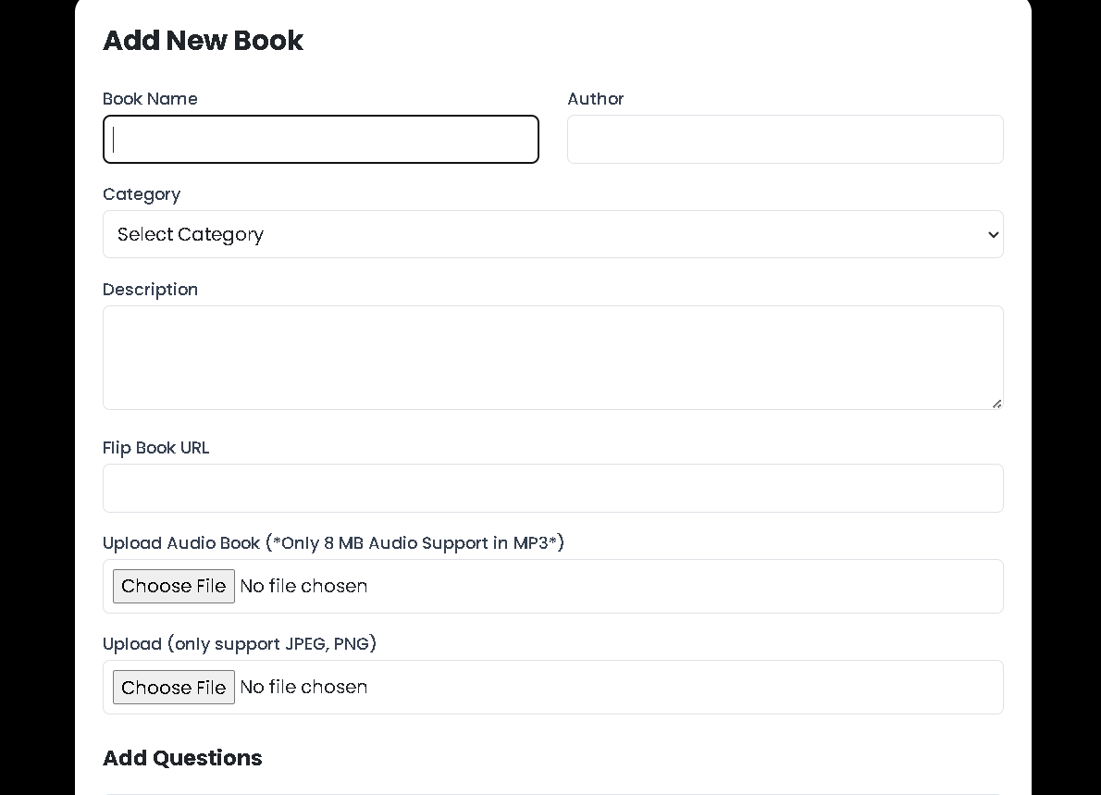

Also I would imagine sometimes I don’t have everything to upload the book , so I want to save all the things I upload in to this book like audio book , then save come back later work on it so it will be very helpful to add a save button , it will just save it but it will only upload it when everything 100% is completed then it will allow to up load .

So add a “save” button above “add book “button please

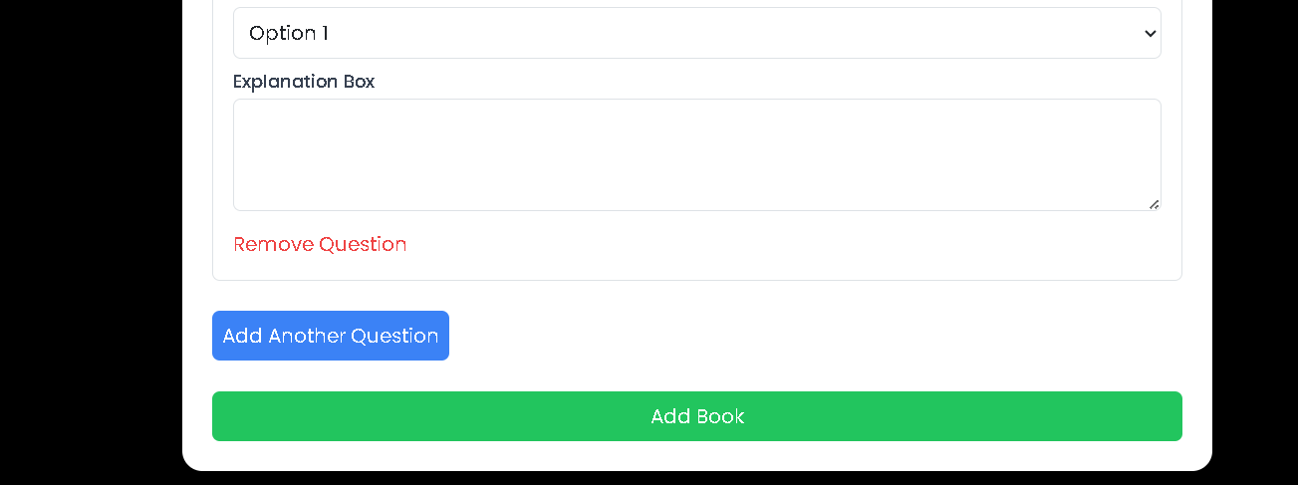

Lastly where do we upload the explanation of test? I guess I did not reach there. Because I see that now after taking test you can see the answers right? If a user try to take the test which he took earlier should see only below and navigate back .